Mason Deja

Mod 5

Table 1. Summary statistics for the BOD amounts for private and state laboratories.

lab n mean sd min Q1 median Q3 max

1 private 11 34.636 10.452 15 28.5 35 40.5 54

2 state 11 25.273 19.683 6 9.5 20 33.5 71

Figure 1. Histogram of BOD amounts for private and state laboratories.

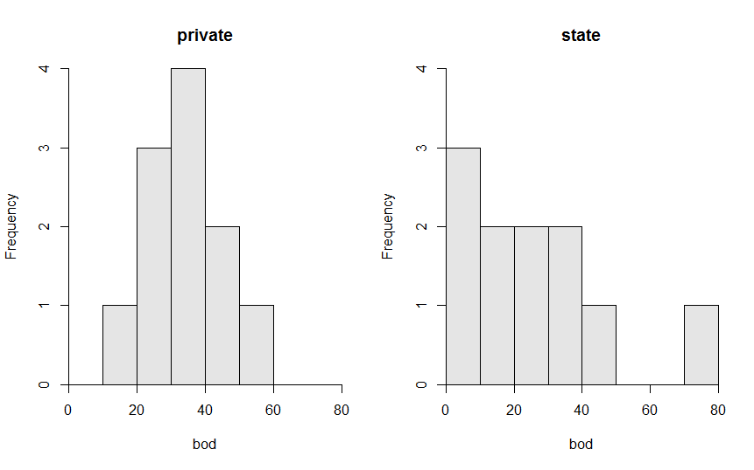

1. The distribution of private bod measurement is symmetrical while the state is more left skewed with an outlier at 80(table1). The center of distribution is 34.636 for private and 25.273 for state, both of these numbers are the mean (table 1). The dispersion is 10.452 for private and 19.683 for state, both numbers were the standard deviation. I chose to use mean/ standard deviation because I found it interesting comparing the two graphs standard deviation because it showed the private data was more usable do to having a lower standard deviation than the state lab.

R code appendix

library(NCStats)

setwd("~/R stuff")

dfobj<-read.csv("sampling.csv")

str(dfobj)

headtail(dfobj)

Summarize(bod~lab,data=dfobj,digits=3)

hist(bod~lab,data=dfobj)

I have neither given nor received unauthorized aid in completing this work, nor have I presented someone else's work as my own.